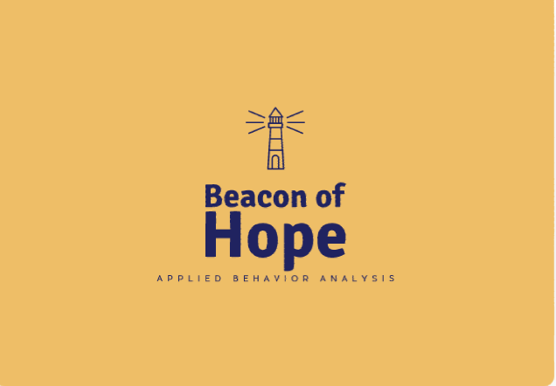

Beacon of Hope Parent Handbook

181 West Reynolds St. Ozark, AL 36330
Phone:
Fax:
Email:beaconofhopeABA@gmail.com
Website: ABABeaconofHope.com

Table of Contents
- Senior Staff Members
- Mission and Program overview
- Attendance and Payment Policy
- Client Services
- Parent meetings and training
- Parent Involvement
General Policies
- Items Needed
- Toileting and Diapering
- Transportation
- Setting of Therapy
- Conflict of Interest
- Communication
- Reporting Child Abuse and Neglect
- Social Media Policy
Emergency and Security Procedures
- Reporting of Communicable Diseases
- Inclement Weather Policy
- Drop off and Pick up Procedures
- Emergency Preparedness Plan
Health Care Procedures
- Client Records
- Accidents/ illness and injuries
- Medication Administration
- HIPPA and Confidentiality Policy
- Complaints

About Us
Beacon of Hope is owned and operated by Lamettra Cox and Shelby DiPilla. Lamettra and Shelby are both board-certified behavior analysts (BCBAs) and Licensed Behavior Analysts (LBAs) who are committed to the Ozark and Wiregrass area and work hard to serve clients from this previously underserved area. Beacon of Hope is the trade name for Centrum ABA which loosely translates to the Center of Applied Behavior Analysis. Both names were developed based on what Lamettra and Shelby wanted to convey and provide to families in the area. If at any time you have questions or concerns please feel free to bring it to their attention.

Lamettra Cox, M.A., BCBA, Owner: Lamettra Cox earned her Bachelor's Degree in Psychology from Post University in 2013 and a Master's Degree at Ball State University in Applied Behavior Analysis in 2016. Lamettra obtained her BCBA in 2018. Population experience consists of working with children with a wide range of developmental disabilities. Lamettra loves working with the families and helping to improve their quality of life. Lamettra also knows what it is like to have a child on the Autism Spectrum. Her oldest child was diagnosed at the age of 3. She states that her son is the reason why she became a BCBA!
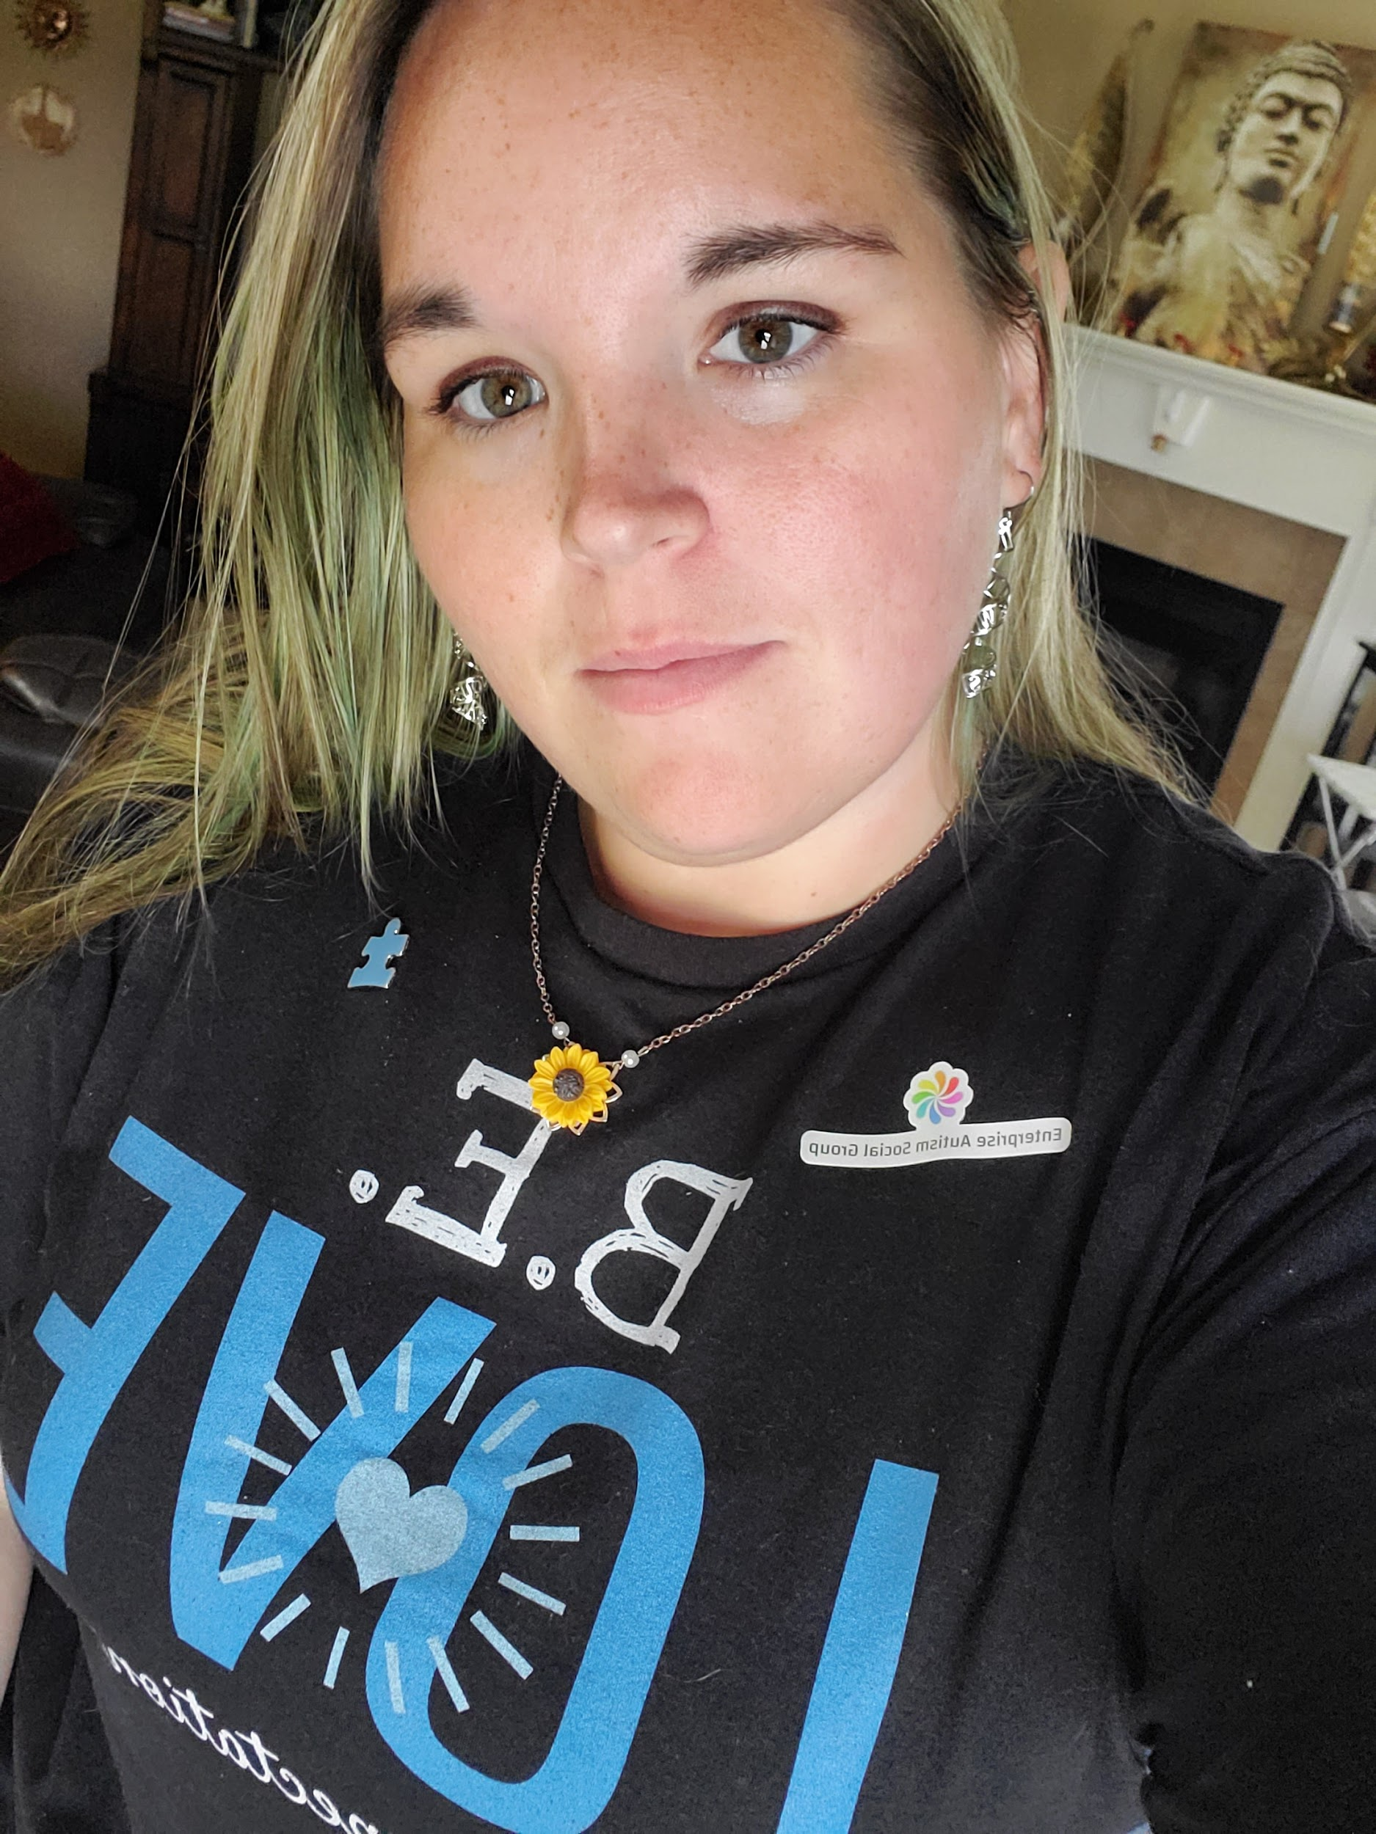Shelby DiPilla, M.A., BCBA, LBA, Owner: Shelby DiPilla earned her Bachelor's Degree in Psychology from the University of West Florida in 2012 and a Master's Degree from the University of West Florida in Exceptional Student Education and Applied Behavior Analysis in 2014. Shelby obtained her BCBA in 2018. Shelby has experience working with clients ages 2-21 and has worked with clients with many co-morbid diagnoses along with Autism. Shelby is passionate about providing community support for those diagnosed with Autism as well as providing ABA services.

Mission Statement
Beacon of Hope strives to provide excellent behavior analytic services to Ozark and the surrounding areas. We collaborate with colleagues across multiple disciplines to enhance and apply evidence-based practices.

Program Overview
Each client’s program is individualized and based on his or her goals and unique learning style. Every client receives an assessment, and, in cooperation with parents, goals, and objectives are designed to meet his or her individual needs. We serve individuals from 1 year of age and up. We provide ABA in a variety of settings to best meet individual needs.

Attendance Policy
Children must arrive on-time and be picked up promptly at the end of the session. This ensures appropriate services are delivered and clinician’s time is effectively and efficiently utilized. Therapists will be ready to meet children at the drop off area. Parents/clients should call the Center at 719-203-6903 if they cannot meet the scheduled arrival or departure times. This will ensure that staff is prepared to receive the child or push back their next session if necessary. More than 3 cancelations in a month with less than 24 hours notice or not showing up for your appointment time will result in a meeting with your child’s BCBA to discuss scheduling concerns before continuing therapy. Early pick-ups affect our schedule and take away from your child’s medically necessary therapy times. More than 3 early pickups in a month with less than 24 hours notice will result in a meeting with your child’s BCBA to discuss scheduling concerns before continuing therapy. If vacations or extended time away from therapy is needed please notify us as far in advance as possible.

Late arrivals take away from the daily planned therapy schedule for your child and it also affects the flow of therapy. Consistent unscheduled late arrivals will result in a meeting with your child’s BCBA to discuss scheduling concerns before continuing therapy. Following will be a scheduled meeting with your BCBA ,if attendance continues to be a problem and your child’s hours may be affected.

We do our best to avoid cancellation of sessions due to therapist illness but it may occur. If your session has to be canceled you will be notified as early as possible. Cancellation will be limited to once per month per client with the exceptions of during holiday closures. Beacon of Hope will be closed for Good Friday, 4th of July, the day before and day of Thanksgiving, Christmas eve, Christmas Day, and New years day. We will have a modified schedule on days that schools are closed. Beacon of Hope may close early for other holidays with advance notice. Once a month on a Friday Beacon of Hope closes at 3pm for staff training.

Payment Policy
Beacon of Hope accepts Tricare, Blue Cross Blue Sheild, Medicaid, and private pay. If using medical insurance there are requirements that must be met for the payer in order to start and continue therapy. Pease assists with documentation when requested.

Co-Pays are due the day that services are rendered. Co-pays more than 30 days late will result in a $10 fee each calendar month that it is not received. Private Pay fees are due 30 days after services are rendered. Invoices will be sent to caregivers. Private Pay invoices that are more than 30 days late will result in a $50 late fee. Private Pay invoices that are not received within 60 days after the due date may result in termination of treatment. Payments can be made in cash, card, or check.

Returned Check Policy
The office will notify you immediately upon receipt of a returned check for the insufficient fund and a $30 initial fee will be assessed. A credit card or cash payment will be due the next business day. Thereafter all payments will have to be made by credit card or cash.

Client Services
We provide Applied Behavior Analysis (ABA) therapy. ABA improves individuals’ quality of life in the following areas: language, motor, social, independent skills, and academic skills. Treatment plans are based on individuals’ skill deficits and target behaviors. Target behaviors are behaviors that are impeding their individual from being able to have a high quality of life. Hours of treatment are based on the individuals’ skills needs. The treatment at Beacon of Hope also plans for generalization of skills and as a result, clients are expected to demonstrate skills across a variety of settings, people, and multiple probes of skills. In order to measure success, data is collected during every session and evaluated by the clients’s BCBA before programs are altered. Our ultimate goal is for our clients to graduate from ABA and for families to acquire the skills necessary to help the individual as independently as possible.
Client and family preferences are taken into account when treatment decisions are being made. We work to recognize the individual’s wants as much as possible. Each therapist pairs with clients in order to create an atmosphere of positive learning.

Parent Meetings and Training
Parents are required to attend at least one 1 hour parent training with your BCBA per month. More meetings may be needed based on treatment plans and client behaviors. Your expectations for monthly meetings are outlined in your child’s treatment plan. Failure to attend meetings can result in the termination of treatment. Insurance payers require that you attend training and meet caregiver goals. Parent training will include treatment plan goals, objectives, fidelity, and review of data collected. Training may take place at the center or prearranged location. Parent training meetings will be scheduled at the beginning of each month. Upon enrollment, parents will receive a parent training binder that they are expected to bring with them to each parent meeting. Additional binders are available for $30.

In order to schedule an additional meeting with your BCBA please request it from them at least one week in advance. BCBAs will not be available for meetings at pick-up or drop-off unless arranged in advance.

Parent and Caregiver Involvement
In order for the client to be successful in behavior change, it requires a team approach. Caregivers are expected to follow treatment plans and be familiar with the client’s goals and programs. Data may be collected within the home and school setting and feedback are given. Coordination of care will occur with all caregivers for whom consent has been given.

General Policies
Items Needed: Due to activities that clients are involved in for therapy and the length of the session the following are expected to be provided by the caregiver at drop-off. Failure to do so will be disruptive to therapy.
- Change of clothing
- Food items including snacks, drinks, and meals if applicable. Please include extra food for your child if they are working on food acquisition programs.
- Diapers and Wipes if applicable
- Items needed for treatment goals could be included but are not limited to toothbrush, toothpaste, hairbrush, or combs.
- Reinforcing items if requested

Toileting and Diapering: We use evidence-based potty training programming, social stories, behavior skills training, positive reinforcement. Negative punishment and punishment not be used as part of potty training. Caregivers are expected to provide materials for potty training.

Transportation: Transportation for community outings may be necessary in order to generalize skills. A transportation agreement will need to be on file and updated every 6 months in order for your child to be transported by Beacon of Hope staff for community outings and field trips. Caregivers are expected to provided car seats if needed. Approved drivers are those who submit proof of a good driving record from the State of Alabama Department of motor vehicles, proof of insurance, vehicle registration and valid driver’s license. Please see your child’s BCBA to fill out a transportation agreement.

Setting of Therapy
The setting of therapy will be determined based on each individual’s behavior goals and staff availability. The setting scan included center, community, school, and home. Clients may take walks in the community during center-based services.

Conflict of Interest
Individuals related to clients receiving services may not serve on the treatment team. In order to protect the confidentiality of clients and their families as well as employees of Beacon of Hope we follow HIPAA guidelines, and employees are encouraged not to interact with current or former clients outside of therapy times. Such interaction includes personal relationships, email, and similar media. BCBAs and RBTs both have a code of ethics that is expected to be followed at all times.

Communication: Communication with Beacon of Hope should take place during business hours via phone and/ or email. Therapists are not available during off-hours and in case of emergency, you should call 9-1-1. The therapist will not engage in communication with caregivers in a manner that could violate HIPAA. If parents would like to receive photos or videos of only their child during therapy please fill out a media release. Media will be solely for the parents to view progress and see the modeling of programs.

Reporting of Child Abuse and Neglect: Any staff member who has reasonable cause to know or suspect that a child has been subjected to abuse or neglect or who has observed the child being subjected to circumstances or conditions that would reasonably result in abuse or neglect will immediately report such facts to the Dale County Department of Human Resources.

Social Media Policy: Our code of ethics prohibits staff from accepting friend requests from clients and their families we serve. Additionally, our code of ethics prohibits identifiable pictures from being posited on staff or company social media. Any photos that are posted on the company page are taken in a way such that the individual can not be identified.

Emergency and Saftey Procedures

Communicable Deiseases: The BCBAs will contact Dale County Health Department to notify them of any reportable communicable illnesses.

Illness Policy: Young children frequently become mildly ill. Infants, toddlers, and preschoolers experience a yearly average of six respiratory infections (colds) and can expect one to two gastrointestinal infections (vomiting and/or diarrhea) each year. Deciding whether to keep your child at home or when to send a client home from the Center can be difficult. It is important for parents and caregivers to discuss what observations have been made and agree on a plan of action. If a specific diagnosis is made, e.g. strep throat, conjunctivitis, etc. please let Beacon of Hope know so other families can be alerted. The following is a guideline and recommendation for exclusion from the Center:
Disease or Symptom Need to stay at home?
- Body Rash with fever Yes—seek medical attention. Any rash that spreads quickly, has open, weeping wounds and/or is not healing should be evaluated.
- Chicken Pox Yes—until blisters have dried and crusted (usually 6 days)
- Conjunctivitis (Pink Eye) Yes—until 24 hours after treatment. If your health care provider decides not to treat your child, a note is needed
- Coughing (severe, uncontrolled coughing or wheezing, rapid or difficulty in breathing) Yes—medical attention is necessary. Note: children with asthma may attend with a written health plan and authorization for medication/treatment
- Coxsackie’s Virus (hand, foot and mouth disease) No—child is no longer contagious once the symptomatic rash appears, unless the child has mouth sores or is drooling
- Diarrhea (watery stools)—infectious Yes, your child should stay at home if not contained within the child’s diaper or child is having two or more diapers within a one hour period. Child may return 24 hours after diarrhea has resolved. Yes, your child should stay at home if the diarrhea is accompanied by an illness such as fever or vomiting.
- Fever Yes—fever over 99 degrees and when fever is accompanied by behavior changes or symptoms of illness, such as rash, sore throat, vomiting, etc. Child may return 24 hours following the resolution of the fever and illness.
- Hepatitis A Yes – until 1 week after onset of jaundice and when able to participate in Center activities
- impetigo Yes – until 24 hours after treatment starts
- Measles, mumps and rubella Yes – these are illnesses that are highly communicable and need to be diagnosed by a physician. Please report any suspicious cases to the Center so that follow-up can occur. If you have any concerns or suspected cases, please call the Center.
- Mild cold symptoms A good rule of thumb is to keep a child home at the beginning of a cold—the most infectious time and when he or she feels the worst. Return to school when he does not have a persistent cough and he or she feels well
- Pertussis (whooping cough) Yes – until 5 days of antibiotic therapy have been completed and a note from a health care provider indicates the child is no longer contagious
- Vomiting (2 or more episodes of vomiting in the previous 24 hours) Yes, the child should stay at home until 24 hours following the resolution of the vomiting. Observe for other signs of illness and for dehydration
- RSV (respiratory syncytial virus) Yes until symptoms dissipate
- Ringworm Yes – until after treatment has started Keep area covered for first 24 hrs of treatment
- Roseola Yes – seek medical advice. A child with an identified rash and no fever may return to the Center
- Strep Throat Yes until 24 hours after starting antibiotics
- Upper respiratory complications - large amount of yellow-green nasal discharge - extreme sleepiness - ear pain - fever (above 101 degrees) Yes—seek medical advice and decide whether your child should be in the Center
- Yeast infections (thrush or candida diaper rash) No – may attend if able to participate in Center activities. Follow good hand washing and hygiene ativities
Child may return 24 hours after the illness has resolved (fever free, diarrhea resolved)

Inclement Weather Policy
In general Beacon of Hope follows Ozark City Schools for closures. Please contact the center if you have a concern about getting your child to or from therapy due to weather.

Drop-off and Pick-up Procedures
A consent form documenting treatment received must be signed at drop-off before caregiver leaves.
Sign-in and Sing-out sheets will be available in the drop-off area.
Once enrolling at Beacon of Hope you will be asked to fill out a surrogate caregiver permission form for each person other than biological parents whom you give permission to pick-up your child. Pick-up persons must have a valid ID. If parents are separated custody agreement must be on file. Please try to inform staff if someone out of the ordinary is picking up your child so we can inform the therapist.

Emergency Preparedness
Clients and staff will practice exiting the building in case of fire.
Additionally, clients and staff will practice a bad weather drill so that client sand staff are prepared in case of inclement weather such as a tornado.
In the event of an emergency, BCBAs or staff will communicate with the parents through a phone call. If Emergency personnel is needed parents will be informed.

Health Care Procedures

Client Records: Our governing body requires us to keep records including data and session notes for a period of seven years and in line with HIPPA guidelines. Parents must sign release forms for behavior plans, session notes, and data. Documents may be requested at any time for the continuation of care. The client’s record could be kept as paper or electronically. Only necessary staff members will have access to files. Release of information may be requested from other providers and caregivers may be asked to sign a release.

Accident, Illness, and Injuries: We strive for your child’s health and safety and do everything we can to prevent accidents from occurring. If an accident does occur we will notify the caregiver immediately and if medical attention is needed it will be provided based on urgency. We will also document any incidents and copies are available if requested. In case of a medical emergency, the center will call 9-1-1 for emergency help. In case of illness, the parent will be notified based on the illness policy outlined above.

Medication Policy: Beacon of Hope will work with parents, physicians and other prescribing health care professionals in administering medication to your child during session times. All necessary forms must be on file before your child can receive any type of medication from our staff. All medicine must be brought to the office in the original container with the prescribed label. Medication will be kept out of reach of clients in a locked container. If the medication requires refrigeration a refrigerator will be provided.

HIPAA and Confidentiality policies: HIPAA policy dictates that client information including medical history and identifying information is not to be discussed with those not relevant to the child’ s treatment. In order to protect confidentiality, the staff has been instructed not to discuss medical information within earshot of other adults at the center or elsewhere. Client files are to use initials instead of full names whenever possible. Client files will not leave the center without medical justification. Release forms are required before information can be shared with other providers. Observation forms are required before parents can observe within the clinic.

Complaints: If there is a concern that arises with your child’s treatment please contact their BCBA. You can schedule a meeting by calling the office. RBTs can not alter treatment plan decisions without the direction of a BCBA. BCBAs and RBTs are certified by the behavior analyst certification board (BACB). If you feel that ethics have been violated you can contact the BACB.com with concerns.

Acknowledgment

I__________________________ have read and reviewed the Beaocn of Hope parent handbook prior to ________________________ begining therapy. I agree to the contents of the handbook. I acknowelge that by signing this form I am agreed to fees at outlined above.

Signature of parent_____________________ Date______________

Signature of BCBA______________________Date_______________

